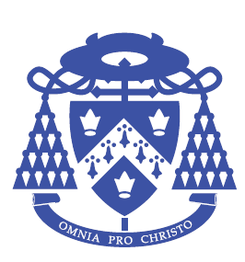 The Cardinal Wiseman Catholic School
Home Languages
2025-2026
Dear Parent/Guardian,
Reference: GCSE and A Level Home Language Exam Entry Summer 2026
Your son/daughter has expressed an interest in completing a public examination this year in the home language that is regularly spoken at home and not taught in this school.
We are always keen to embrace other languages and to facilitate the exam process and so we offer this opportunity to students who are in Year 9 or above.
If you would like your son/daughter to be entered for a GCSE or A Level exam in their home language, please read and complete the form below.
The form must be returned to me by 2nd December 2025.
Yours faithfully,
Mrs Kaur
Exams Officer
(Room B11)

Student Name: -------------------------------------------------------------- Tutor Group:-----------------------------
Language: -------------------------------------------------------------- GCSE or A Level?--------------------------
- I would like my child to be entered for the home language examination detailed above.
- I confirm that my child can speak, read and write fluently in the language requested.
- I understand that my child will NOT be given any formal tuition in the language at Cardinal Wiseman, but will be told where to find information about the course content, and outline of the exam.
- I will ensure that my child will complete all controlled assessments on time and attend any meetings called.
- I will also ensure that my child will sit all the required exams.
- I understand that failure to adhere to these requirements will result in me paying the cost of the examination.
Parents’ signature: -------------------------------------------------------------- Date: ---------------------------
Parent’s name: -------------------------------------------------------------- (in block capitals)
Student’s email address: ---------------------------------------------------------------------

